**An Analysis Using Avocado Prices to Determine the Best Cities to Live in.**



*Source: http://realitypod.com/wp-content/uploads/2013/01/Sydney-australia-32220119-1920-1200.jpg*

*Presented by* **Celina Akwo**

**October 30th 2019**

**Overview**

This analysis uses the prices of avocado to determine the best cities to live in.Using the data I collected, I decided to use Tableau Public Desktop because it easily accepts data from any source regardless of the data type. Meaning I did not have to convert the data from one form to another which would have been the case if I used SAS Programming. Also, Tableau public has many free versions and is very flexible.

1. I downloaded the data from the following link [https://www.kaggle.com/neuromusic/avocado-prices in .csv](https://www.kaggle.com/neuromusic/avocado-prices%20in%20%20.csv) format. Then I inserted the data into Tableau Desktop. I started by plotting a bar graph showing Regions and Consumption of Avocado. The graph revealed that HartfordSpringField had the highest consumption and Houston the lowest.

**Fig.: Showing consumption of Avocado per city**

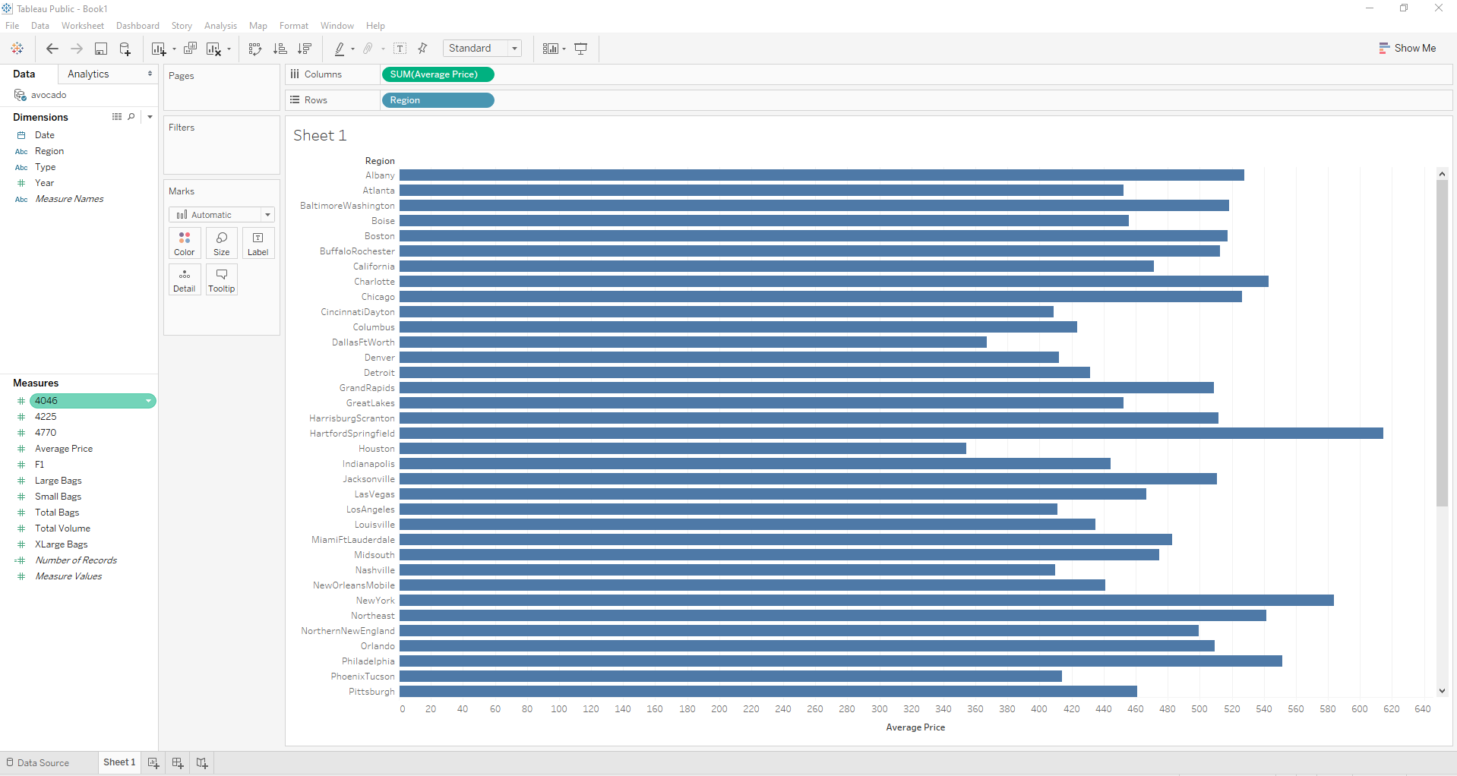

2) Next I decided to plot another graph to show geographical regions. This made it possible quickly glance and know which cities are selling Avocados the most expensive. This graph showed that cities like Seattle, Tempa, Boston, Boise, etc sell Avocado more expensively than any other city in the dataset. This analysis shows that, if I want to save money on Avocado then I should not stay in those cities. I used bigger circles to show cities that sold avocados more expensively and smaller circles to portray less expensive avocado prices.

**Fig. 2: The cities highlighted are those you do not want to worry about**

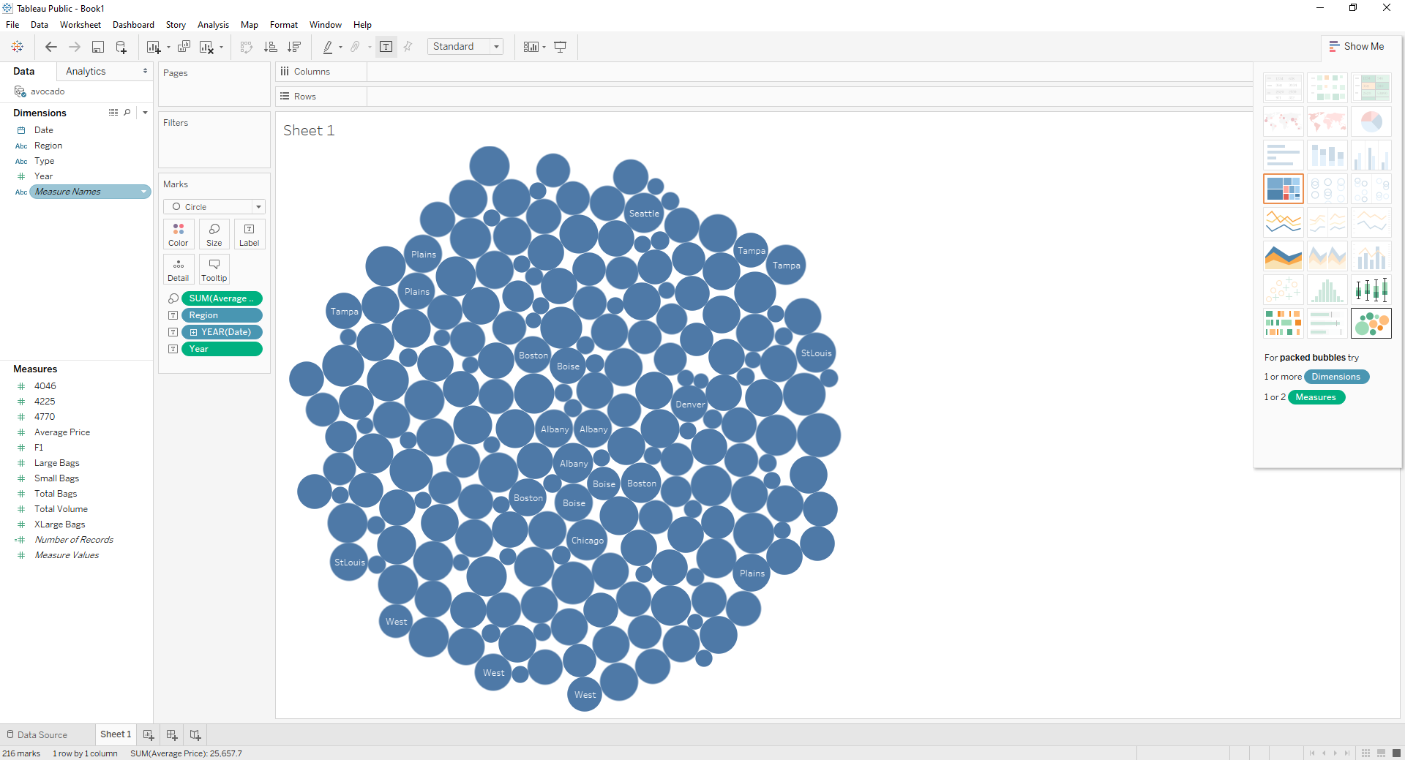

3) When discussing product prices, it is alsoimportant to talk about quality. I decided to compare the prices of conventional vs organic avocado to get a glimpse at the ways in which each city as pricing each kind of avocado. The results I got were outstanding. I used the HartfordSpringfield average price for conventional avocado which is 1.408 while organic is 2.229. Then I used another city, California’s Conventional is price is 1.397 and organic is 2.211. The results showed that HartfordSpringfield is similarly as expensive city as California with the price of conventional avocado being more expensive than Organic avocado in Houston for about 1.27. This means, living in Houston could be cheaper if it provides quality products for cheaper prices. From the graph, we can also deduce that Houston is a less expensive city to live in since its conventional price is 0.825 and Organic 1.27.

***Fig 3: Graph showing Average Prices for Conventional Avocado for HartfordSpringfield***

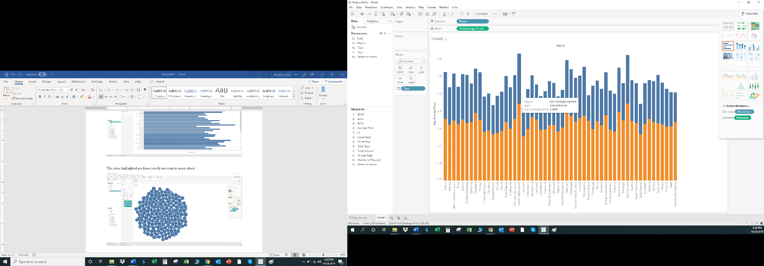

**Fig 4: Graph showing Average Prices for Conventional Avocado for Texas**

: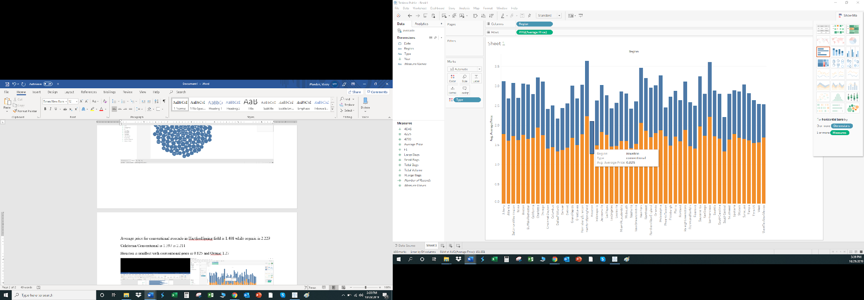

**Fig 5: Graph showing Average Prices for Organic Avocado for Texas**

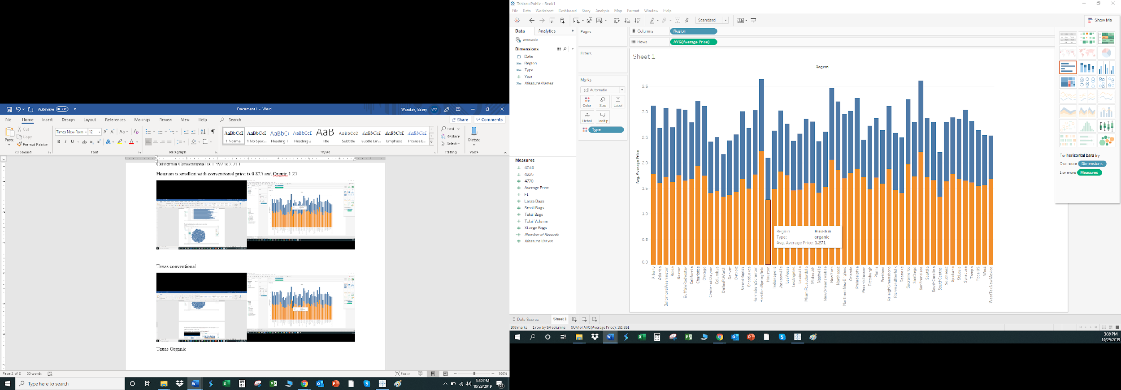

***Fig 6: Graph showing Average Prices for Conventional Avocado for San Francisco California***

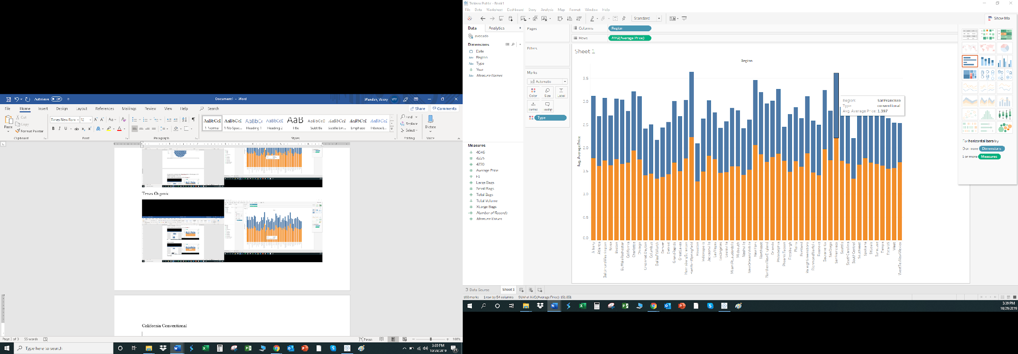

**Fig 7: Graph showing Average Prices for Organic Avocado for San Francisco California**

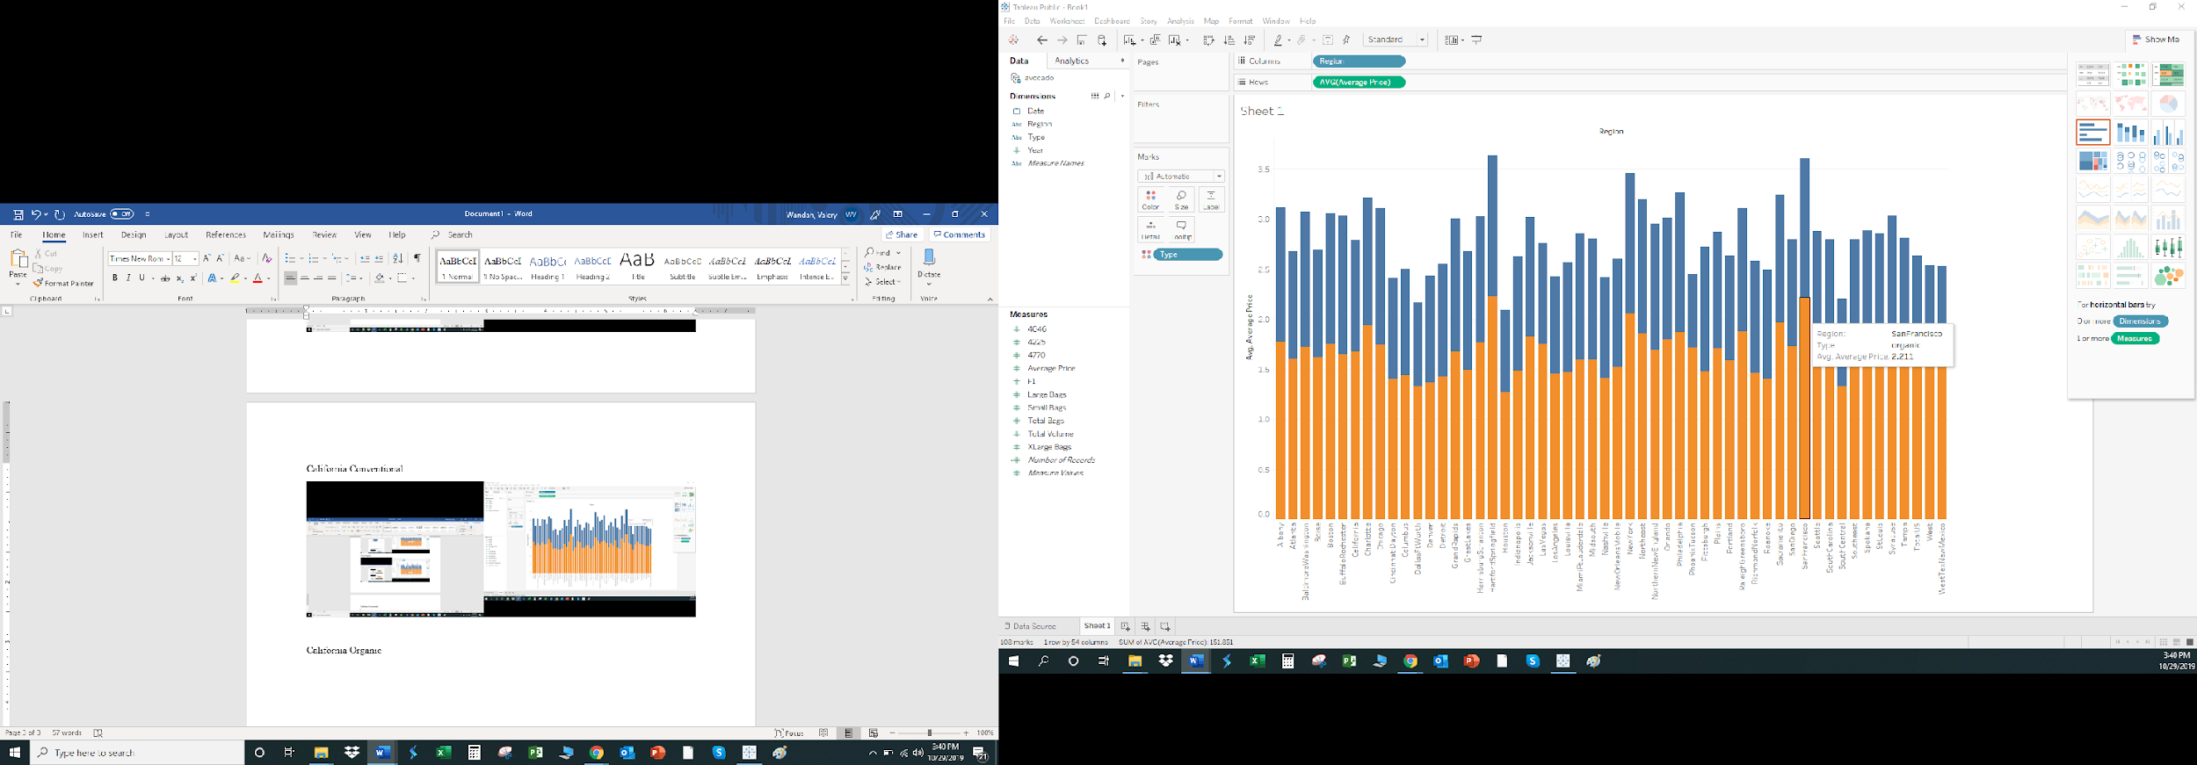

4) In an attempt to find out if people prefered consuming Conventional to Organic Avocado, I plotted a graph for Average Price Vs Conventional Avocado. It showed the maximum prince is only

**Fig 9: Average Maximum Price of Organic Avocado by Region**

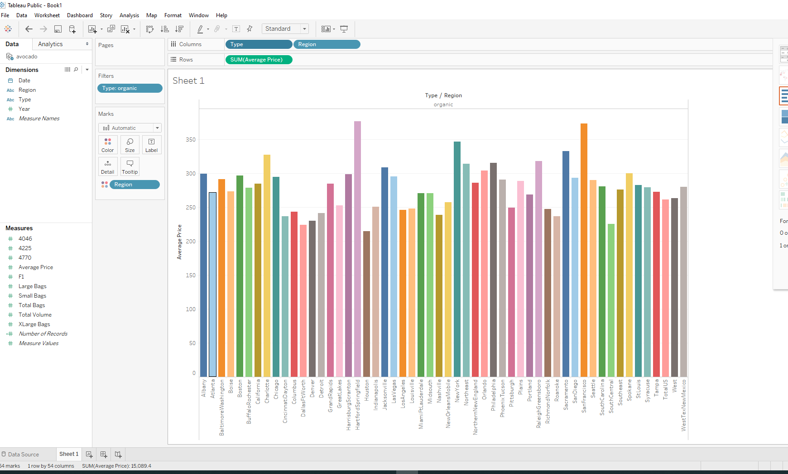

**Explanation:** Based on the data shown in the two graphs it is clear that people are trying to live healthier lifestyles in cities. They are willing to pay more for organic avocado compared to conventional avocado even with the maximum for the organic avocados going up to 350. This also means more sales of organic products are higher than conventional products.

5) It is important to not only search for affordable cities to live in, you also want to know whether what you are consuming is healthy or in line with what others are consuming in that city. To answer that question I decided to plot a graph of consumption of avocado over a 4 years span. The graph showed that Consumption of Avocado has increased from 2015 to 2017. But started declining from 2017 both in consumption of conventional and organic avocado. Overall 2018 was the lowest year in consumption that depicts that many people might be trying to cut down on avocado consumption, which could mean lower wages or products are becoming generally expensive regardless of quality.

**Fig 10: Comparing Average Price of Avocado over 4 years span.**

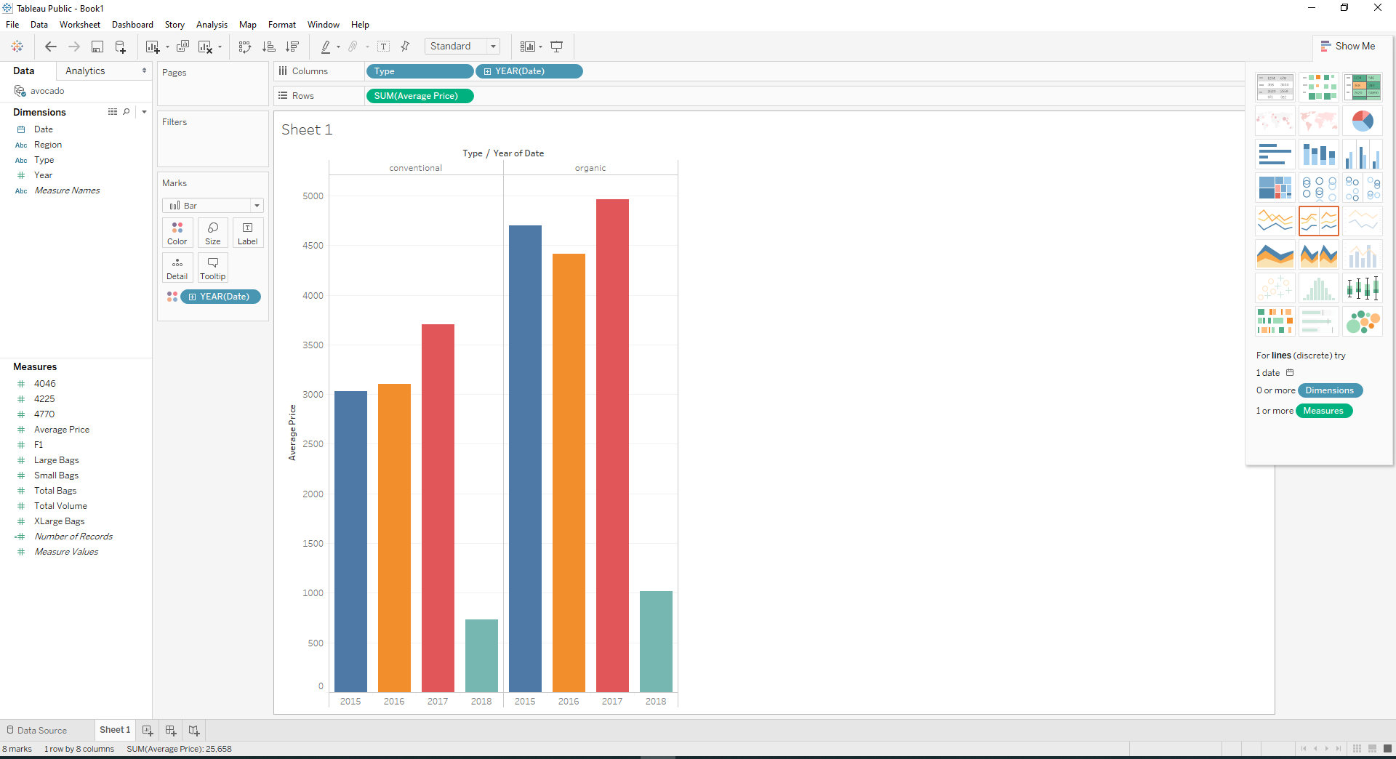

6) When it comes to saving money we want to always consider all available options. Sometimes buying in bulk can save you money while other times it may cost you more.

To explore this I decided to plot average price Vs small/large/xlarge bags of both Conventional and Organic Avocado

**Fig. 11: Screen Shots Comparing Average Price Vs Quantity of Product Purchased**

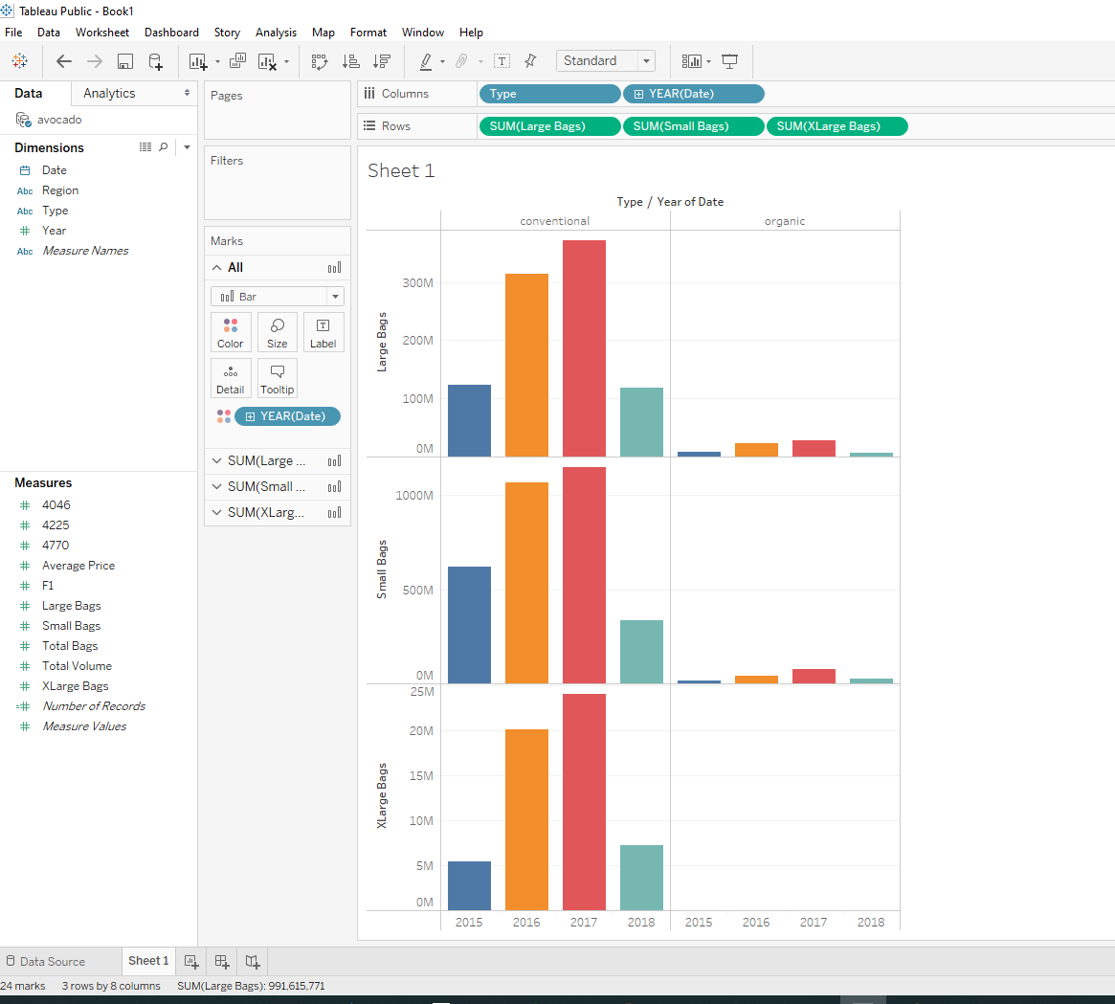

**Explanation:** While the consumption of small, large and XLarge bags was similar increasing from 2015 to 2017 and declined in 2018 for conventional avocados. The average prices only increased from 2015 to 2017 for small, large bags of organic avocado. Then X Large bags of avocado were not purchased at all for organic products. It shows that many people either could not afford to buy XLarge bags of organic avocado or it is not economical at all.

7) To know which years had Highest Average Price I decided to graph years vs average price and that gave the following results. It showed 2017 was the year with highest sales of avocado which is in line with previous graphs.

**Fig 12: Screen Shot showing Average Prices of Avocado for different years**

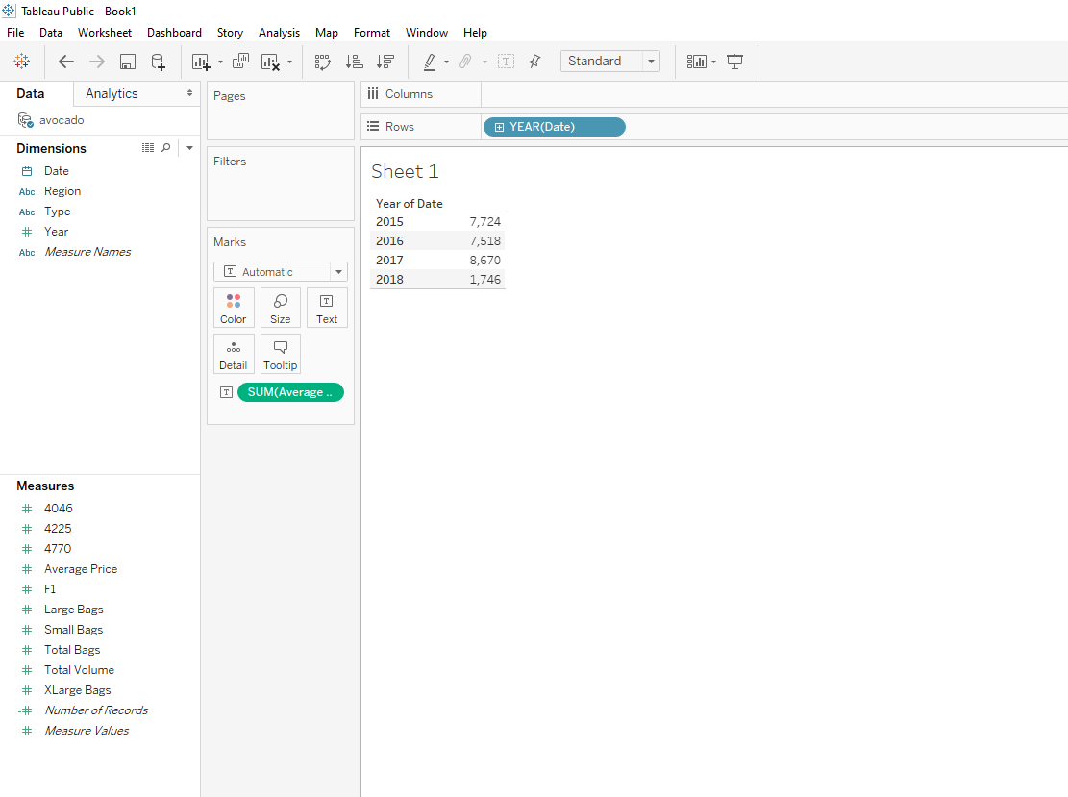

8) Consuming Avocado at various times of year can also be due to certain conditions like its availability due to the weather. When I analyzed the data it showed that January was the month with highest consumption while June was the month with lowest consumption of Avocado. This could mean two things: availability and cheaper prices in January then shortage and more expensive during summer which is June.

**Fig 13:** **Screenshot showing average price of avocado during months of year**

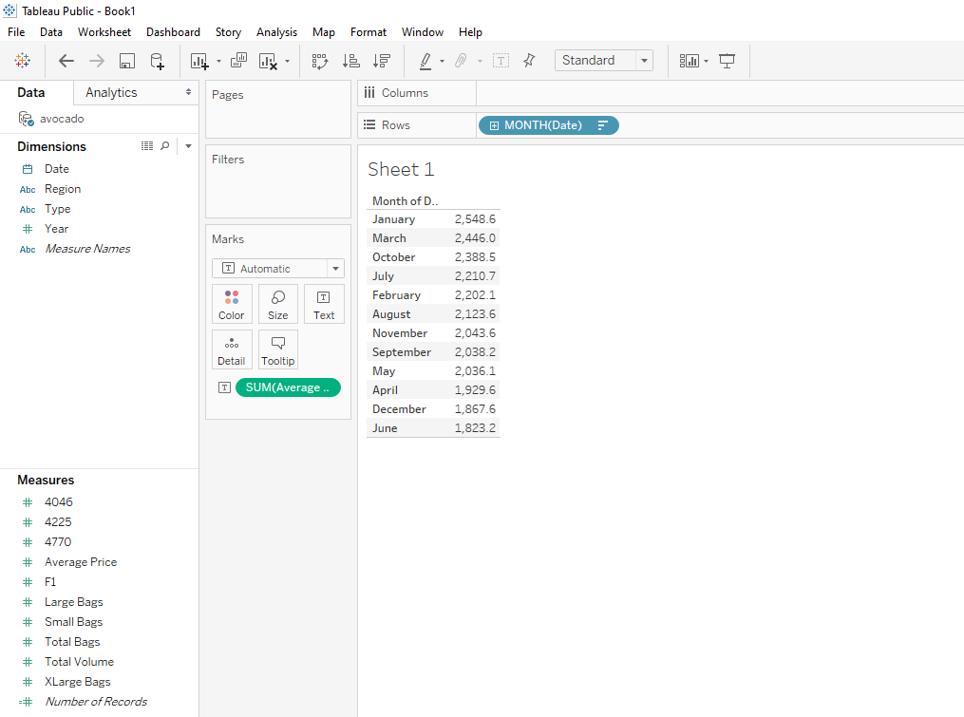

**Fig 14:** **Screenshot showing average prices by months of year.**

To further save money knowing when to buy too can affect your budget. For example, looking at a screenshot of the type of avocado and average price in various months shows that in January Organic avocado is twice and one and half times more expensive than it is in June. So June is the best time to consume organic avocado for both most and least expensive cities.

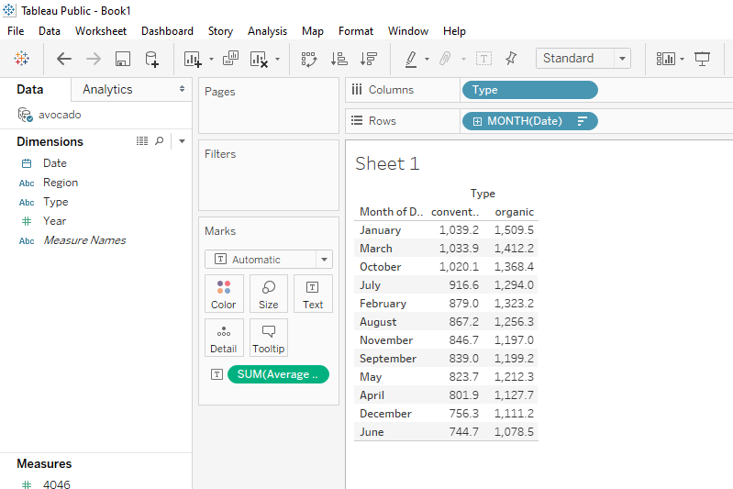

Conclusion

Looking at the analysis, Texas will be the best city to live in for many reasons. The prices of quality products there are less expensive. The most expensive cities will be Hartford SpringField followed by San Francisco California. This means you can eat healthy at a smaller budget. The difference overtime will be a lot of savings.

**Assumptions**: On the contrary, if the data presented here were used by sales people, it will be very useful to note that Conventional Avocado sells very well in small cities than in large cities as those in big cities try to eat healthy and quality products as in organic. Another vital information will be to avoid stocking a store with XLarge bags of avocado in the cities as you will not sell that much or at all.